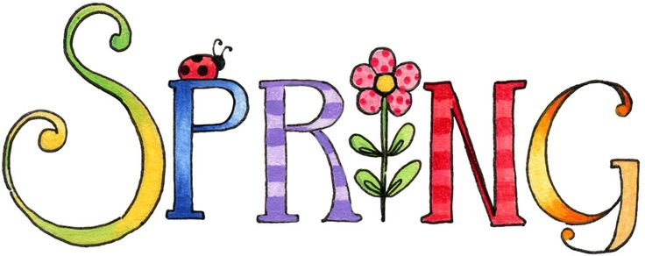
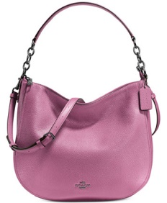
Sunday April 26, 2020 at 2PM
Doors open at 1:00 PM

20 games of bingo PLUS Mother’s Day Raffle
Door Prizes, 50/50 Raffle, Lite Lunch Foods, Snacks, Desserts and Good Times. Join the FUN!
YOU MUST BE 18 OR OLDER TO ATTEND.
This event is in no way sponsored, endorsed or approved by any of the manufacturers.
NO TICKETS WILL BE ISSUED - your name will be registered for check-in at the front door on the day of the event. If you wish to pay by credit card, please go to our website at www.olfnewcastle.com and hit the parish fund raising payments link on the main page. You can then fax in your form below to 302-328-6318 or email us your information at rectory@olfnewcastle.com. We will send you a confirmation email. For payment in cash; checks made payable to Our Lady of Fatima (Memo: Bingo) or for more information, please contact Rachel Pompetti at (302) 824-4285 OR the Rectory at (302) 328-3431.
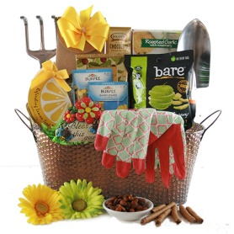
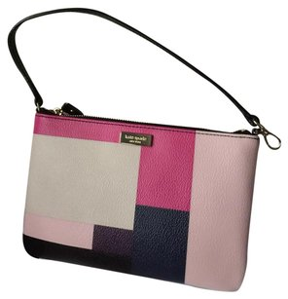
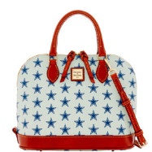
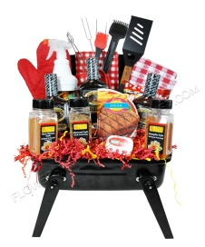
Table of 8 SPECIAL DRAWING: Reserve & pay in advance a table of 8 to win designer item

PLEASE COMPLETE AND RETURN THE BOTTOM PORTION

Name: Telephone Contact:
Number of tickets: x $25 each = (amount enclosed)
Reserved table of 8 participants (individual names needed):
1) 5)
2) 6)
3) 7)
4) 8)
Please return envelope to Rectory in envelope marked “Bingo.” Thank you! See you there!

