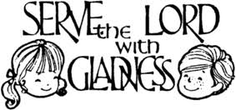

WANTED
New altar Servers
For Our Lady of Fatima
Serving at the altar is a privileged way to draw closer to Jesus, which in turn "enables you to open yourselves to others, to journey together, to set demanding goals and to find the strength to achieve them." "The closer you are to the altar, the more you will remember to speak with Jesus in daily prayer; the more you will be nourished by the word and the body of the Lord, the better able you will be to go out to others, bringing them the gift that you have received, giving in turn with enthusiasm the joy you have received.” - Pope Francis
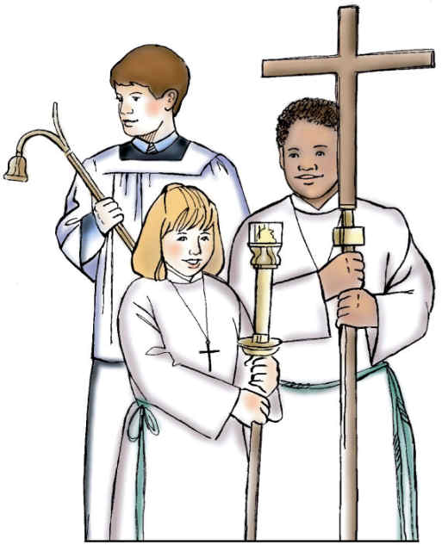
If you are in Grade 4 – 10, have received Holy Communion and would like to serve at the Altar of God for weekend Masses; Holy Day and special Parish celebrations, please call the Liturgy Office at 322-3745 ext. 20 or Email mlmay@olfnewcastle.com for more information. You may also call the Rectory to leave your name and contact information.
Altar Servers are REALLY important! This is one way that you, the youth of the parish – yes, YOU can serve the Lord. Server training is provided and schedule is personalized to meet your family needs.
Being Altar Server is call to Prayer and Mission - Pope Francis
E-MAIL: prep@olfnewcastle.com

- Reasons for becoming an Altar Server
There are lots of reasons for becoming an Altar Server. Let’s take a look at why becoming one might be one of the best things you could do. You’ve most likely seen them at Mass, up by the altar, helping the priest to keep the Mass running smoothly. Their age ranges from seven upwards and they’re normally wearing robes which look very similar to that of the priests, but have you ever considered doing the same? Here are seven reasons why becoming an altar server might be one of the best things you could choose to do.
1.You learn why we do everything in the Mass
You can learn a lot about the Mass by serving at the altar. Sure, swinging the censer (the smelly incense thing) is kind of fun but why is it that we do it? By becoming an altar server you begin to learn these things and it makes all the symbols of the Mass so much more understandable and interesting.

2. You get fully involved in the Mass and get more out of it
We can get more out of Mass through serving at the altar. Very much linked with the last point, when you start to understand why we do something you get so much more from it. More than this though, by serving at the altar you pay more attention to the whole Mass to help you remember where your part fits in. By focusing and understanding what’s going on, the Mass can then lead you into a much deeper relationship with God and you feel the impact of Mass far greater!

3. You make some great friends
Altar serving can lead to making lots of new friends! By becoming an altar server you’ll be meeting up with many of the same people every time you serve at Mass. With a great range of ages and experiences, you’ll meet some fantastic people you’d probably meet nowhere else. As your friendship develops, you’ll end up having many friends who all share your faith and this can lead to some brilliant conversations and great memories.

4. You learn some fantastic life skills
Altar serving can teach you lots of valuable skills. Communication, teamwork, perceiving what needs to be done and doing it, punctuality, self-confidence, and the list goes on. Serving on the altar is a great place to start building these skills. You’re supported by all your fellow servers, you have quite a large responsibly and rules to guide you. Even if you do something wrong, nobody in the congregation notices so basically it’s always a winning situation!

5. You become more involved in the community
You can get to know your community better through altar serving . By taking up a responsibility at Mass you start to recognize more and more people in the church in general. This slowly changes your experience of the church community, from a group of random people you stand next to at Mass, to a large and diverse family who you can meet and chat with every time you go and make you feel truly at home in your church.

6. It helps you discern your vocation better
Whether marriage, consecrated singlehood, religious life or priesthood, altar serving can help you understand your vocation. Far and away the best reason to do altar serving is that it helps you discern your vocation better. Every vocation (whether marriage, consecrated singlehood, religious life or priesthood) is awesome and leads us to a greater and deeper understanding and relationship with God. Altar Serving is a great way to begin to see that beauty more fully in both priesthood and religious life.

7. It gives you a greater appreciation of the priesthood
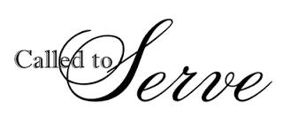
You can gain a greater appreciation of the priesthood by altar serving. Even if you are not discerning priesthood, by altar serving you learn so much more about the priest you work with. This is great because it allows you to both fully appreciate his human side while also appreciating much more the sacramental grace he’s been given in holy orders!

