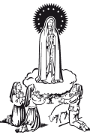
Our Lady of Fatima
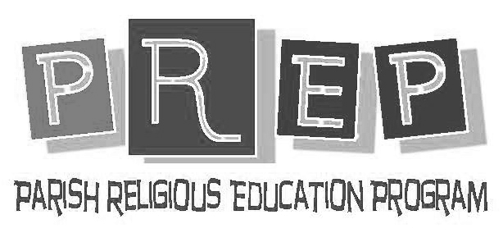

Hacer de la educación religiosa Make the religious education
de sus hijos una prioridad! of your children a priority!

WHO: Children in K–8 who DO NOT ATTEND A CATHOLIC SCHOOL should be registered for Religious Education classes. Los niños de K-8 que NO ASISTEN A UNA ESCUELA CATOLICA deben registrarse para clases de Educación Religiosa.
Students meeting requirements to receive Sacrament of Eucharist or Confirmation. Estudiantes que cumplir con las requisite para recibir el Sacramento de la Eucaristia y la Confirmacion.
WHEN: See schedule on back for more information. Vea el horario en la p/arte posterior para más información.

“Train up a child in the way he should go and when he is old, he will not depart from it.”
Proverbs 22:6
REQUIREMENTS FOR REGISTRATION REQUISITOS PARA EL REGISTRO
Copy of Baptismal Certificate needed for all new registrations Copia del certificado de bautismo necesaria para todos los nuevos registros

REGISTRATIONS HELD IN PARISH LITURGY CENTER:
DATES: SATURDAY 6:00-6:45 PM July 22, July 29, August 12 and August 26
SUNDAY 1:00-2:00 PM July 16, July 23, July 30, August 13 and August 27
REGISTRATIONS HELD IN RELIGIOUS ED CENTER:
TUESDAY 5:30-7:30 PM July 25 and August 15
WEDNESDAY 5:30-7:30 PM July 26 and August 16
THURSDAY 5:30-7:30 PM July 27 and August 17
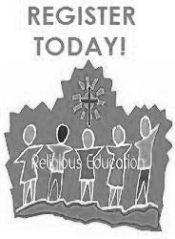
PLEASE CHOOSE ONE OF THESE DATES AND TIMES POR FAVOR ELIGE UNA DE ESTAS FECHAS
TO REGISTER YOUR CHILD(REN) FOR PREP 2017-18 Y HORAS PARA REGISTRAR A SU NIÑO(S) PARA EL PREP 2017-18
Thank You Gracias

For more information please call (302) 328-0307 or Email: prep@olfnewcastle.com
Para obtener más información, llame al (302) 328-0307 o
Email: prep@olfnewcastle.com

LATE FEES APPLY BEGINNING MONDAY, AUGUST 27, 2017.
LAS TASAS DE TARDE SE APLICAN INCLUYENDO LUNES, 27 DE AGOSTO DE 2017.

